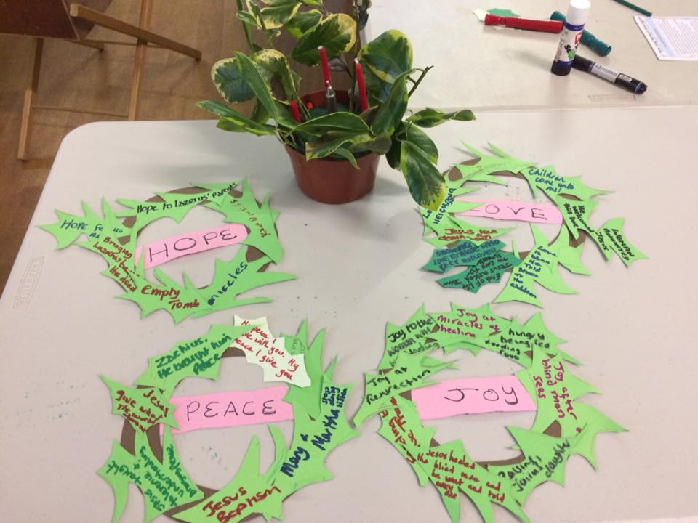



Worship

Service

Learning and Caring

Evangelism

**Welcome**



Hello and Welcome to New Song Network Warrington. We are a growing church that has a variety of opportunities for worship, discipleship, and fun for all ages.

We believe in being welcoming; we not only sing our faith, but live it out in very practical and tangible senses. This is done in many varied ways, for example through the Hot Drinks Ministry or collecting advent calendars for the Food Bank. if you would like to be involved please speak to any of our team, our welcomers or Rev. Linda Bishop.

Bless you and welcome,

New Song Warrington

Leadership Team

At New Song Breakfast last week, we thought about how the Advent themes of Love, Peace, Joy and Hope are shown in the Nativity story and throughout Jesus’ life.

What bible stories can you associate with Joy, Love, Hope and Peace? What songs do we sing related to each of those?

Merry Christmas and a

Happy New Year!

December 2017 - January 2018

Loving God, Loving People, Making Followers of Jesus

**New Song Network Warrington**

**New Song at a Glance….**

*Fridays are Rev. Linda Bishop’s day off; please don’t contact her on that day.*

*New Song Kids: 1st Sunday afternoon, 3.30—5.30pm at Bold Street (7 January)*

*Feast for Faith: 1st Wednesday evening, 6:30pm/7:30pm at the Manse (10 January)*

*Discipleship: 2nd Sunday evening, 6.30pm at Latchford (14 January)*

*New Song Breakfast: 3rd Sunday morning, 9am at Latchford (21 January)*

*New Song Café: 7pm at Bold Street (28th January)*



**New Song Network Warrington Quiz Night**, hosted by Simon Chesterson. March 10th opening at 7pm for a 7:30pm start, at Grappenhall Ex-Servicemen's Club, Chester Rd, Grappenhall, WA4 2QG. Quiz and 2 course meal, with plenty of parking and a bar! There will be a raffle on the night.   
Tickets are £8 for adults and £5 for under 16s, available from Kit. Please book tickets so we can ensure sufficient food. There will be a Veggie option available, please state when booking.   
All proceeds will go towards the work of New Song Network Warrington.

Thank you for your patience; our email addresses are now finalised. If you want information or to speak to someone from the church use:

*newsongwarrington.info@gmail.com.* If you want prayer for yourself or someone else it is: *newsongwarrington.pray@gmail.com*. Kit is co-ordinating both of these for the time being.



For those not on Facebook, a conversation started by Linda led to a New Song Carol Sing in the lovely new Warrington Market on Sat 9th December. The carol sing was great and really well received! Dave Thompson from the Warrington Disability Partnership joined us.

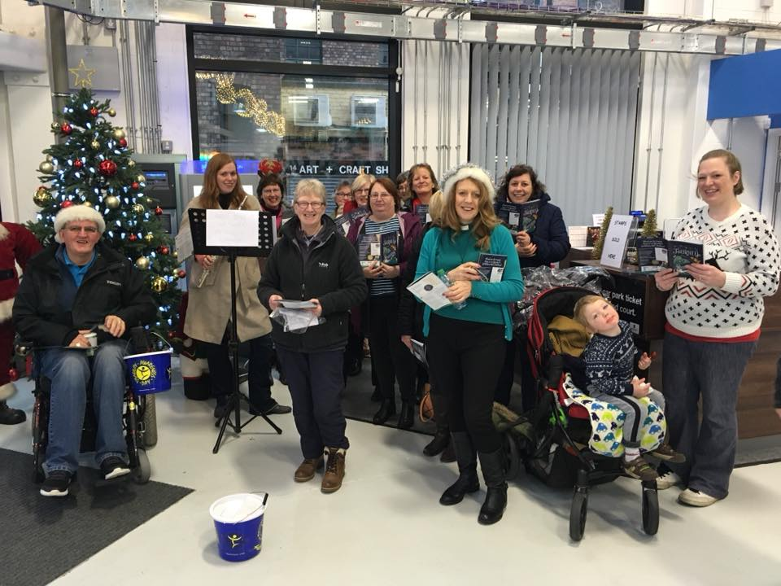



If you don't have other arrangements you will be very welcome to join with our friends at Latchford on Christmas Eve at 7.30pm for a service including Holy Communion and at Bold Street on Christmas Day at 9.30am.



**Feast Your Faith** will be on Weds 10th January (not 3rd). All welcome at Rev Linda's for food at 6.30 and discussion at 7.30pm. Please let Linda, Kit or Facebook know that you are coming, in order for food to be prepared.



New Song Café on 28th January will be our Covenant service including Holy Communion.



Don’t forget, if you ever can’t make it to New Song Café, you can follow along on our twitter feed (@NSWarrington) and also on the Facebook event page as we’ll be live as we go through the evening. It’s a way to be part of the community whilst not physically in the building. Be part of the conversation!



**Christmas Hot Drinks Ministry**. Thanks to all who have already offered to help with Hot Drinks Ministry at the Crem and Fox Covert cemetery. We could really do with a couple of extra helpers on Christmas Day, ideally from midday to 2pm and helping with packing up. If this is for you, please email alice_squires@hotmail.com. If you can bring a donation of cakes, sweets, biscuits, chocolates etc to Cafe on Friday, we can definitely make use of them. Prayers are also gratefully received.



**Can you help out?**

What would NSC be without cake, NSB without bacon butties, or NSK without pizza? We haven’t got anyone signed up for **serving refreshments** at either service for the next few months. Breakfast (Cook, serve and clear away breakfast at Latchford MC – 8:15-9am.) Café (Help serve 6:15-7pm, or 7:45-8:15pm; clear away at end 8:45-9:30pm. You can sign up for separate times or the whole evening.) Can you and a friend put your names down on the sheet in the foyer; or a small group get together to do this? We would all be hugely grateful…. Otherwise no cake or butties!

There are also a number of jobs that we need help with.

**Helpers at New Song Kids** on 1st Sunday afternoon of the month, again on a rota or just occasionally. Help with craft, stories, games or general help with primary age children.

Could you **coordinate the Prayer Chain**? You would send out prayers for special occasions and world events and respond to people’s requests using a distribution list.

Help is always required for **setting up for Café**! 4:30-5:30pm on the day. Just turn up!

Could you **manage the Welcoming Rota** for Breakfast or Café? We hope to have a list of people who are willing to help, so organisation would be needed before the dates.

Could you be **back up pushing buttons** on the *previously setup* Light or Sound desk?

Could you use Facebook to follow along with the worship to ‘**Facebook Live’**?

If you think you could help with any of these, speak to Amy or Kit for more information or to volunteer!



If you would like to talk to Rev. Linda Bishop or someone else in New Song, please leave your details and you will be contacted.



We’re trying to build a community on the Facebook page and group, so please join our group for updates and discussions.



During the break at Café if you would like someone to pray with you, people are available in the Doncaster Chapel (off the foyer).

**Connect with God: Bible Reading Plan**

Knowing God begins with reading the Bible. Yet reading isn’t always so simple. Each week, read the passage and consider the question. Join us on Facebook to find the reading and a discussion. Join us to create an online House Group!

**w/c December 24:** *Genesis 21-23.*

How would you see God if you were Sarah? Hagar? Ishmael? Abraham? How would the conversation go between you and God? If you were Abraham or Isaac, how would this episode change your understanding of God?

**w/c December 31:** *John 6:27-6:71.*

What was Jesus’ answer when the crowd asked how to get on God’s good side? Why at this point, did many people desert Jesus? What keeps you from walking away from him?

**w/c January 7:** *Genesis 24-26.*

The God-life means believing God and entrusting him with even the smallest details of your life. How consistently do the people in this reading do this? How consistent are you? What do these details tell you about god’s love and patience?

**w/c January 14:** *John 7:1-7:24*

What is it about Jesus that people find so unbelievable? Even his own brothers had trouble believing what he said about himself. What about Jesus challenges your faith? What about him silences your doubts?

**w/c January 21:** *Genesis 27-29*

What made Jesus so dangerous that the Pharisees wanted to arrest him? Is ‘dangerous rebel’ the first thing that comes to mind when you think of Jesus? Why or Why not? What does it mean in your life to follow a subversive like Jesus?

**I***n what we’ve looked at so far, consider – how did your understanding of who God is and the ways he works change?*



**New Song Network ®**

**Warrington**

Bold Street Methodist Mission,

Palmyra Square North, Warrington,

WA1 1JQ

Latchford Methodist Church,

Thelwall Lane, Latchford, WA4 1LH





**Find Out More**

You can find out more

in the following ways:

**Website:**

www.newsongwarrington.com

**Facebook:**

New Song – Warrington

New Song Network

**Twitter:**

 @nswarrington

To find out more about **fresh expressions** and the journey of New Song, Please visit the fresh expression website: www.freshexpressions.org.uk

**Email:** To make contact about anything in this newsletter or about New Song in general: newsongwarrington.info@gmail.com



The advent candles represent Hope, Peace, Love, and Joy, reminding us of the hope we have in Christ, the peace he brings, the love God has for us, and the joy we have in Christ.

Loving God, we thank you for the hope you give us, the peach you bring us, the gift of love you show us, and the joy you bring us. Help us to prepare our hearts to receive this gift of the Lord’s coming. Bless our worship. Help us live holy and righteous lives, guide us in all that we say or do, and help us to hear and do your word. We ask it in the name of the one born in Bethlehem. Amen