

**New Song Network ®**

**Warrington**

Bold Street Methodist Mission,

Palmyra Square North, Warrington,

WA1 1JQ

Latchford Methodist Church,

Thelwall Lane, Latchford, WA4 1LH



**Connect with God: Bible Reading Plan**

Knowing God begins with reading the Bible. Yet reading isn’t always so simple. Each week, read the passage and consider the question. Join us on Facebook to find the reading and a discussion. Join us to create an online House Group!

**w/c March 25:** *John 10*

What does “more and better life than [you] ever dreamed of” (10:10) look like in your world? Given Joseph’s long struggle, “more and better” certainly doesn’t mean easier. How will you respond if this doesn’t mean easier for you either?

**w/c April 1:** *Genesis 42-44.*

Why did Joseph treat his brothers so harshly? How would you have treated them if you were Joseph and possessed a level of power second only to Pharoah’s?

**w/c April 8:** *John 11.1-11.37*

Ask yourself the same question the Jews asked: If Jesus loved Lazarus, why didn’t he keep him from dying? Why doesn’t God do what we want him to do when we want him to do to it?

**w/c April 15:** *Genesis 45-47*

Why did God want Jacob and his family to move to Egypt, a place where the inhabitants would even eat with them, must less intermarry with them? What was God up to? And what insight does this give you into God’s plan for your life?

**I***n what we’ve looked at so far, consider – which of these people sound like you? What is God trying to teach you through their mistakes?*



**Find Out More**

You can find out more

in the following ways:

**Website:**

www.newsongwarrington.com

**Facebook:**

New Song – Warrington

New Song Network

**Twitter:**

 @nswarrington

To find out more about **fresh expressions** and the journey of New Song, Please visit the fresh expression website: www.freshexpressions.org.uk

**Email:** To make contact about anything in this newsletter or about New Song in general: newsongwarrington.info@gmail.com



Buying a new Bible for yourself or someone else? Want some help with understanding the Bible or want to start journaling? Do you need some dyslexia-friendly resources? These and many more books and related items can be bought from the Bible Society. NSN is part of their More Than A Book programme so when you order quote church number 12211 (or select NSN from the drop-down menu) as you go through checkout and NSN will benefit.  
https://www.biblesociety.org.uk/products/

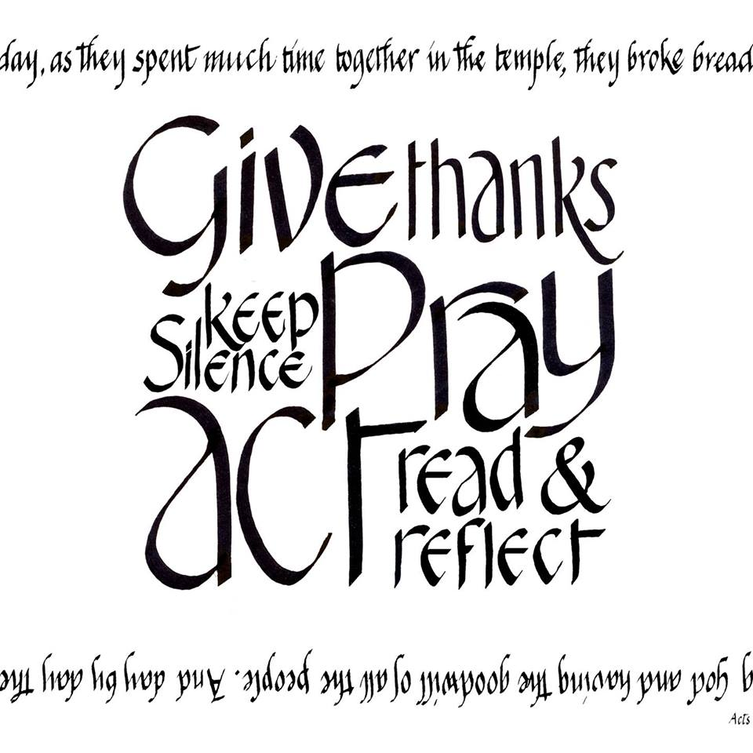

A big thank you to all who helped at the Hot Drinks Ministry on Mother’s Day, and those who have helped and will help with what could be one of our biggest outreaches in Warrington, the Easter Egg Hunt on Easter Saturday.

Tonight we welcome Rev. Loraine Mellor (President of Conference) to New Song Café. I wonder what her impression of New Song Café will be? When New Song Café first started she was the Circuit Superintendent. Will she see a different place? A fresh expression? Will she see us ‘Loving God’, ‘Loving People’ and ‘Making followers of Jesus’ as we live out our faith in practical and tangible senses as well as singing here tonight?



Worship

Service

Learning and Caring

Evangelism



**New Song at a Glance….**

*Fridays are Rev. Linda Bishop’s day off; please don’t contact her on that day.*

*New Song Kids Easter Egg Hunt 11-2pm 31st March (No NSK on Sunday 1st April)*

*Feast your Faith: 1st Wednesday of the month, 7pm at the Manse (4th April)*

*Discipleship: 2nd Sunday evening, 6.30pm at Latchford (6 April)*

*New Song Breakfast: 3rd Sunday morning, 9am at Latchford (15 April)*

*New Song Café: 7pm at Bold Street (22nd April)*

March – April 2018

**Welcome**



Hello and Welcome to New Song Network Warrington. We are a growing church that has a variety of opportunities for worship, discipleship, and fun for all ages.

We believe in being welcoming; we not only sing our faith, but live it out in very practical and tangible senses. This is done in many varied ways, for example through the Hot Drinks Ministry or collecting advent calendars for the Food Bank. if you would like to be involved please speak to any of our team, our welcomers or Rev. Linda Bishop.

Bless you and welcome,

New Song Warrington

Leadership Team

Loving God, Loving People, Making Followers of Jesus

**New Song Network Warrington**





Don’t fancy shuffling around Dunham Massey for an Easter Egg Hunt? Come to Bold Street Café for a Free Easter Egg Hunt from 11am-2pm on Saturday 31st March. We’re hoping to have lots of people coming from Warrington town centre on Easter Saturday to spread the good news of Jesus. Pass on the information to any children and families you know, and if you can pass on any fliers, please take some tonight. We could also do with some adult help to make teas and coffees in the café and direct people in. Let us know if you can spare an hour to help! If you can’t be there on the day, please hold the event in your prayers.



A message from Kit: “I am delighted that **Jayne Adamson** is taking over as the lead lay person for New Song Network Church. Because we aren't a traditional church we don't call her the senior church steward but co-ordinator! Can I thank you all for the support you have given me as New Song has taken its first steps and I know you will give Jayne that same support. “



For the next few months we will be serving a continental breakfast at New Song Breakfast instead of sausages and bacon butties. Instead of asking for volunteers to arrive at 8.20am to start cooking we will only need help to serve the drinks from 9am. However, if you would like to cook bacon and sausages let Kit know and we can have the occasional butty morning!



In order to comply with relevant regulations & legislation, it is *mandatory* for all who hold a position of responsibility and/or work with children/vulnerable adults within the Methodist Church to have the correct paperwork in place and to have recently attended **Safeguarding Training**. If you think this may apply to you, please contact the New Song Safeguarding Co-Ordinator, Alice Squires, or speak to Linda Locke, Safeguarding Officer for the SV Circuit. Safeguarding Foundation Module Training Session is scheduled for *28/04/18*; Refresher Training will be on *12/05/18*. Contact Linda L via the CRC to book a place. Further sessions are in the pipeline and we aim to have all the relevant people in New Song up to date as soon as possible. If you need an up to date DBS, speak to Alice. If you have any concerns in connection with Safeguarding, please speak to Alice, Linda L or Rev Linda Bishop.



**Quizzers!** Feeling sad that you’ve finished the Century Quiz? Been to the Quiz Night? Need something new? There is a new New Song Network Warrington Quiz! This time it’s a wordy one! Get a £1 quiz sheet from any New Song event, and answers need to be back to Amy for checking by 3rd June.

Having marked the **New Song Century Quiz sheets** and counted up any missing answers, wrong answers and disputable answers the winner of the prize is Kit Heald! Special mentions go to Linda Ogden, Miranda Coe and GM Offord from Rixton Methodists. Well done everybody! I hope you enjoyed doing it. It raised £22.



Don’t forget, if you ever can’t make it to New Song Café, you can follow along on our twitter feed (@NSWarrington) and also on the Facebook event page as we’ll be live as we go through the evening. It’s a way to be part of the community whilst not physically in the building. Be part of the conversation!

A massive **thank you** for all the help and support at the Quiz night. We made £767.84, with an extra £120 on the raffle. The Thai meal made a profit and raised £99.20. Thank you everybody again for the help and support – we all enjoyed it!



We’re changing the way that New Song Network Warrington uses **Facebook.** We currently have a Page (New Song Network) and a Group (New Song – Warrington). From April, we will be using the Page as the main presence on Facebook. The Group will be used for Discussion, Prayer and Fellowship. If you’re not sure whether you’re following both, check Facebook or speak to Amy for help.



This July, **Rob Bell** returns for his first UK tour in eight years. Blending his usual mix of philosophy, comedy, theology and subversive insight, The Holy Shift Tour explores this ancient, complex, subtle, mysterious word HOLY and what it looks like for us to reclaim this word in all its hidden depth to help us make sense of the modern world. Doors open at 7.15 with the show starting at 8pm on 6th July at St Helens Theatre Royal.



Our next **New Song Warrington Meal** out will be 29th April, 12pm at Evenwood Farm, Sandymoor. Come along for a Carvery, meal or even just coffee, amazing cake and chat! Let Amy or Facebook know if you intend to come so that we can save you a seat!

We are so excited for **Creamfields 2018**! (Thurs 23 August – Sun 26 August) Interested in being involved? Fill in the online form to register your interest and we will keep you updated!

http://www.123formbuilder.com/form-3106662/We-Are-The-Church-At-Creamfields-2018-Register-Your-Interest



**Help needed!** We need people to be in the foyer at New Song Café to welcome people. This is an especially important job if someone is coming for the first time. If you can help, please speak to Kath in the foyer at the break.



A big **thank you** was received from Trinity Kings Cross for all our kind donations, which enabled so many families in need to receive Christmas hampers. They were so grateful.



Do you feel called to **pray** whenever you hear about a tragedy? Do you sometimes feel praying on your own is difficult and overwhelming? Maybe you could be the NS person to share prayers via our Prayerchain? Sharing and knowing that others are praying with you, for you and about the same situations can be very comforting and worthwhile - please speak to Linda B, Jayne or Kit if you would like to get involved.



During the break at Café if you would like someone to pray with you, people are available in the Doncaster Chapel (off the foyer).



**Text4Prayer** is a circuit initiative enabling anyone to request prayer by texting 07452 958 955. Make use of the number yourself if you wish, but the aim is to leave the cards in public places for others to pick up.



If you would like to talk to Rev. Linda Bishop or someone else in New Song, please leave your details and you will be contacted.