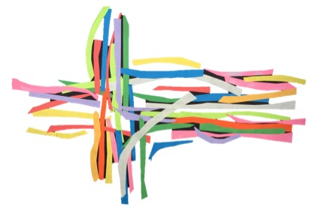



At **NSN Deeper: Afternoon** will be an Advent group on at 1:30pm on Mondays from 26th Nov to 17th Dec, looking at how the Christmas story has been represented in art across the world. As well as the art works being on display we will look at how they have been influenced by the culture of the countries or areas they were painted in. We may even learn some recipes from those places too! All welcome to join in with "Born in us"; it's a lovely way to journey through Advent.



**Carol Singing** in Warrington market. On Saturday 22nd December we have 3 time slots to sing (11-11.30, 12-12.30 and 1-1.30) and would love as many voices as possible. We will also be around with a New Song **Prayer tree** where people can put prayers on stars.



**Hot Drinks Ministry.** If you haven’t yet signed up, but would like to help with this fantastic outreach, please speak to Alice Squires.



This Christmas, we are collecting for a number of causes:

* new socks, and new or used trainers, boots and shoesfor **Room at the Inn**.
* sanitary ware for the **Red Box Project**, a project that puts a box of sanitary ware for girls in schools.
* Warrington market have become a collection point for us for the **Food bank**. This month the bank needs: Toilet rolls, jam, shampoo, tinned fish, tinned puddings and tinned carrots.
* Warrington market have also joined us in collecting Advent Calendars, so we currently have a lovely HUGE pile for the Food bank. Thank you everyone!



Our Christmas **film night** is on 1st December at 5:30pm. Tickets £5 and if you come to one, you get your next film for half price! Any requests, or suggestions, let us know!



**New Song at a Glance….**

*New Song Kids this month: 1st Sunday, 3:30pm at Bold St (2nd Dec)*

*Feast your Faith: 1st Wednesday, 6:30/7:30pm at the Manse (5th Dec)*

*New Song Deeper: Afternoon: 2nd (12th Nov) and 4th (26th Nov) Monday, 1:30pm at Latchford*

*New Song Deeper: Evening: 2nd Thursday evening, 8pm at Jayne’s house (13th Dec)*

*New Song Breakfast: 3rd Sunday morning, 9am at Latchford (16th Dec)*

*New Song Café changed to* ***Friday*** *at Bold Street, listen out for the time!(21st Dec)*

*Fridays are Rev. Linda Bishop’s day off; please don’t contact her on that day.*

November - December 2018

Loving God, Loving People, Making Followers of Jesus

**New Song Network Warrington**





Our New Song **Bamboo** travel mugs have arrived! We are selling them for £5, with £1 per cup going to New Song. We hope that this will make enough to be able to allow us to give out cups in our Welcome Packs and at Hot Drinks Ministry. Speak to Jayne Adamson if you’d like more information or to put in an order.



We are again collecting for the **Trinity Kings Cross Hamper appeal** who give hampers to families whose names are given to the project by Halton social workers and health visitors. The hampers contain basic food, toiletries and cleaning materials plus suitable gifts for each person in the family. If you have any items to add before 1st week in Dec, please speak to Kit.



Each church within the circuit has been tasked with producing a **Growth Plan,** demonstrating our commitment to grown NSN Warrington. Thiswill be sent to the circuit by 30th November. Watch this space for further opportunities to help support us in our mission to be Church in the Community.

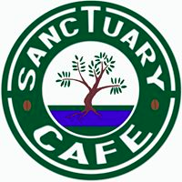



As part of our plan for growth, the leadership team have set **themes** for the rest of the church year, which will be used at each of the New Song events, including New Song Deeper. The themes are based on the Sacraments of the Methodist Church. After a brief competition on Facebook, each of the themes has a (new) song title!

Jan: Splish Splash, I was taking a bath!

Feb: It takes two, baby!

Mar: Lay me down, in a blaze of Glory!

Apr: Gotta have faith!

May: I did it my way!

June: It’s all about you!

July: All you need is love!



On Saturday 1st December, before our Film night, we will be gathering at 3pm at Bold Street to walk to the Market giving away mince pies and details of **NS events** en route.  We will be finishing at **Prayer tree** in the market to chat and promote the tree, and offer and opportunity for prayers etc before walking back to Bold Street for the film.



**Selfie?** We now have a NS-Warrington Selfie frame! We’d love you to take a selfie with it and post it on social media. How many selfies can we get?



**New Song Network ® Warrington**

**Rev. Linda Bishop:** 01925 416780‬ or lindabishop@hotmail.com

**Website:** www.newsongwarrington.com

**Email:** newsongwarrington.info@gmail.com

**Facebook:**

New Song – Warrington

New Song Network



During the Oct and Nov New Song Café, the **Sanctuary Cafe** based in Lymm will be bringing cards, bibles and gifts to sell. They will accept cash or cheques.